Molecular Studies on Antimicrobial Resistance Genes in Multiple drug resistant Salmonella Servoars and Staphylococcus aureus Isolated from Chickens .
Ashraf A. Abd El Tawab¹, Seham N. Hamouda² , Maryam S.Dowidar³
¹Bacteriology, Immunology and Mycology Dep., Fac. Vet. Med. Benha Univ. ²Animal Health
Research Institute" Tanta Branch". ³Directorate of Vet. Med. " Tanta Branch"
ABSTRACT
A total of 400 samples were collected from 100 broiler chickens represented by 100 for each of muscle ,liver, heart and 50 for each of spleen and joint from chicken flocks in Gharbia, Egypt during the period from February to June 2016. All samples were subjected for isolation of Salmonella and S.aureus, antibiograms and application of PCR screen on resistant genes. The incidence of Salmonella and S.aureus were 11 (2.75%) and 41(10.25%) respectively. For Salmonella the predominant servoars isolated were S.Infantis (36.36%) , S.Typhimurium (18.18%) , S.Stanleyville (18.18%) , S.Magherafelt (9%) , S.Sinchew (9%) , S.Ratchaburi (9%). All Salmonallae and S.aureus isolates (100%) showed multidrug resistance. All Salmonella isolates were sensitive to amikacin and gentamycin., Salmonalla isolates showed several antibiotic resistance by variable difference from 100% for pencillin, oxacillin , spiramycin and vancomycin to 27.2% for norfloxacin and cefoxitin. S.aureus isolates showed several antibiotic resistance by variable difference from 100% for oxacillin , ampicillin ,pencillin ,spiramycin to 12% for ceftriaxone and amikacin, By using PCR, For Salmonella showed that 9 isolates harbored blaTEM gene ,Sul1 and floR (9/9)(100%) , 7 isolates harbored ereA and tetA (7/9)(77.7%), 6 isolates harbored aadA1 , class 1 integrons (6/9) (66.6%) and only one isolate harbored qnrS gene (1/9) (11.1%). But for S.aureus showed that 3 isolates harbored mecA gene (3/6) (50%) and 4 isolates harbored femA gene (4/6)
( 66.6%).
Keywords : Antimicrobial Resistance ,Chicken, Class I Integron, PCR.

1. INTRODUCTION
Antimicrobial resistance is now recognised as one of the most evidence of political traction, with endorsements of statements by the WHO and US Centers for Disease Control and Prevention describing a global crisis and an impending catastrophe of a return to the pre-antibiotic era. (Organization, 2014). Amongst the foodborne pathogens, Salmonella and S.aureus are the most common and frequent pathogens responsible for food poisoning and food related infections. Salmonella is a leading cause of enteric diseases in human and animal with millions of illness worldwide, whereas the non-typhoidal Salmonella species as a zoonotic agent are also predominantly associated with food borne infections (Akbar and Anal, 2013). The increased level of antimicrobial resistance observed in Salmonellae has become a public health issue. The development of resistance in Salmonellae to antimicrobial agents is attributable to one of several mechanisms such as production of enzymes that inactivate antimicrobial agents through degradation or structural modification, reduction of bacterial cell permeability to antibiotics, activation of antimicrobial efflux pumps, and modification of cellular drug targets (Crim et al., 2015) Penicillin was the first choice of antibiotics to treat staphylococcal infection. In 1944, by destroying the penicillin by penicillinase. More than 90% S.aureus strains were resistant to penicillin. However, methicillin, semi synthetic penicillin, was used to treat Penicillin Resistant S. aureus but resistance finally emerged (Hendriksen et al., 2011). Methicillin resistance arises due to the acquisition of the mecA gene, which encodes an alternative penicillin-binding protein, PBP2a which has a low affinity for β-lactam antibiotics (Weese, 2010).Integrons are mobile DNA elements with the ability to capture genes and can integrate gene cassettes, usually antibiotic resistance genes, by site-specifc recombination . To date, ten integron classes have been identified and, among them, class 1, 2, and 3 integrons have been implicated in antibiotic resistance.
This study aimed to investigate the incidience of some Antimicrobial resistance genes in multi-drug resistant isolates of Salmonella and S.aureus recovered from broilers in El-Gharbia ,Egypt.

2. MATERIALS AND METHODS
2.1. Sample collection:
Hundered broilers : ( 100 sample from muscle , 100 sample from liver , 100 sample from heart , 50 sample from spleen and 50 sample from joint ) were collected from different farms in El-Gharbia Governorate , Egypt between February to June 2016 then transferred to Tanta animal health laboratory under aseptic condition in ice box .
2.2. Bacteriological examination : Isolation and identification of Salmonella servoars and S.aureus.
2.2.1.Salmonella servoars :
2.2.1.Salmonella isolation and identification:
The procedure of isolation of Salmonella was carried out according to the standard methods recommended by ISO 6579 (ISO, 2002). Typical colonies of Salmonella on XLD agar were pale pink with black center while on Salmonella-Shigella (S-S) agar salmonella colonies appear pale color with or without black centers .Smears from the suspected Salmonella colonies were stained with Gram’s stain and microscopically examined. Suspected colonies were identified as Salmonella spp. based on their colony morphology on selective media, and the biochemical testing using TSI agar, Urea agar, L-lysine decarboxylase, Voges Proskauer, Methyl red tests, Simmon's Citrate and Indole tests (Cruickshank et al., 1975). Finally ,Salmonella isolates were serotyped based on slide agglutination for O and H antigens according to Kauffmann-White (1972).
2.2.2. The procedure of isolation and identification of S.aureus was carried out according to (Quinn et al., 2011).
2..3.Antimicrobial Susceptibility testing of Salmonella and S.aureus (Finegold and Martin, 1982) : By using the agar disc diffusion method on Mueller Hinton agar (Oxoid) plates. Twenty-one discs used were ampicillin (AMP) (10µg),penicillin (P)(10µg), cefoxitin (FOX) (30µg), ceftriaxone(CRO)(30µg), cefotaxime (CTX) (30µg) ,cephalothin (KF)(30µg), aztreonam(ATM)(30 µg), amoxicillin-Clavulanic acid (AMC)(30µg), oxacillin(OX)(10µg), nalidixicacid (NA)(30µg), norfloxacin(NOR)(10µg), enrofloxacin (ENR)(5µg), tetracycline (TE)(30µg), amikacin(AK)(30µg), gentamycin (CN)(10µg) ,streptomycin (S) (10µg) , chloromphenicol© (30 µg),erythromycin E (15 µg ) , spiramycin SP ( 100 µg ) ,vancomycin (30 µg ), sulphamethoxate-trimethoprim (SXT) (25µg) (Oxid,UK). The interpretation of inhibition zone of tested culture was according (CLSI.2014).
2.4- Detection of resistance genes and Class I integron using Polymerase chain reaction (PCR) for Salmonella and S.aureus
Oligoneucleotide primers were designated according to Integrated DNA Technology. The primers sequences were illustrated as in Table (1).
2.2.4.1.DNA extraction and purification :
The extraction was done by QIAamp® DNA MiniKit (Cat. No. 51304, Qiagen) used according to manufacturer’s instructions.
2.2.4.2.Amplification and cycling protocol :
for conventional PCR Using of PCR 1.1x ReddyMix TM Master Mix (Thermo SCIENTIFIC) with Cat. No. AB0575/LD-A.
2.2.4.3.Detection of PCR products: (Sambrook et al., 1989)
Aliquots of amplified PCR products were mixed with gel loading buffer and electrophoresed in 1.5% agarose gel

3.RESULTS.
3.1. Incidence of Salmonellae and S.aureus among the examined samples:
3.1.1.Salmonella:
The Culturing and Serotyping identified 11 Salmonella isolates of 400 samples (2.75%) that belong to 6 serotypes distrubed as following 5% in liver, 4% in muscle , 2 % in heart and 0% in spleen and joints (Table 2). The predominant servoars isolated in this study were S.Infantis (36.36%) , S.Typhimurium (18.18%) , S.Stanleyville (18.18%) , S.Magherafelt (9%) , S.Sinchew (9%) and S.Ratchaburi (9%) .
3.1.2. S.aureus:
Out of 400 examined chicken samples coagulase positive S.aureus incidence was 10.25% (41 isolate). distrubed as following 18% in muscle, 11% in liver . 7% in heart . 6% in spleen and 4% in joints.(Table 3).
3.2.Antimicrobial Susceptability testing for Salmonella and S.aureus:
By Antimicrobial sensitivity test all Salmonalla and S.aureus isolates (100%) showed multidrug resistance (MDR;resistance to 3 or more antibiotics). Resistance percentage for Salmonella and S.aureus as shown in (Table 4 and 5).
3.3.PCR results for detection of resistance genes in Salmonella and S.aureus:
For Salmonella : 9 isolates out of 11 examined salmonella isolates harbored blaTEM gene ,Sul1 and floR (100%) , 7 isolates out of 11 examined salmonella isolates harbored ereA and tetA (77.7%) , 6 isolates out of 11 examined salmonella isolates harbored aadA1 and class I integron (66.6%) and only 1 isolate out of 11 examined salmonella isolates harbored qnrS gene (11.1%). (Table 6)
For S.aureus : 3 isolates harbored mecA gene (50%) and 4 isolates harbored femA gene ( 66.6%) .(Table 7)

4.DISCUSSION
The present study tries to illustrate the problem of Antimicrobial resistance in Salmonella servoars and S.aureus in chicken in El-Gharbia Governorate,Egypt.
4.1.Salmonella:
Out of 400 examined chicken samples, 11 isolates (2.75%) of Salmonella spp were detected (Table 2) .This is aggreable with Chiu et al., ( 2010) and Akbar and Anal., (2013) who isolated Salmonella from chicken by (3.4%) and (5.2%) respectively . The incidence of Salmonella in chicken liver samples was 5 % higher than chicken meat samples (Muscle) (4%) and chicken heart samples (2%) while joint and spleen samples were free from Salmonella. (Table 2). Nearly similar results of incidence of Salmonella in different organs detected by Abd-Elghany et al., (2015).Serological identification of Salmonella (Table 2) confirmed the isolation of 6 Salmonella servoars as the following: S.Infantis (36.36%) , S.Typhimurium (18.18%) , S.Stanleyville (18.18%) , S.Magherafelt (9%), S.Sinchew (9%) and S.Ratchaburi (9%) .This reflects the role of chicken as a potential source of zoonotic non-typhoidal salmonellosis in human as S.Typhimurium was mostly associated with human illness.(Hendriksen et al., 2011).It was noticed that, Salmonella Infantis (36.3%) was the most predominant isolated Salmonella serotypes from broiler carcasses and organs. This Agree with Akbar and Anal., ( 2013) and Kaushik et al., (2014) who found that the most predominant serotype in chicken was S.infantis (56.36%) and (75%), respectively. Emergence of multidrug-resistant Salmonella species has a great impact on human health (Abd-Elghany et al., 2015). All Salmonella serotypes showed MDR to ≥ 3 (100%) of the 21 Antimicrobial tested as shown in Table (4) that was similar to the previously recorded studies by Abdel-Maksoud et al., (2015) who recorded MDR Salmonella isolates by 100% in Cairo. In the current study, it was found that Salmonella isolates were resistant to NA ,ENR and NOR by (72.7% ), (27.2%) and (27.2%), respectively as shown in Table (4). These result were agreed with Ahmed and Shimamoto .,(2012) .These results counter El-Sharkawy et al., (2017) who found that S.infantis shows good sensitivity to fluorinated quinolones. Among the β-lactams, Salmonella servoars resistance to to Pencillin ,Oxacillin (100%) , was found the highest, followed by Ampicillin , Azteronam (63.6%) , Cefotaxime (90.9%), Cephalothin(81.8%), Ceftriaxone(72.7%), AMC (18.1%), Cefoxitin (9%).(Table 5) These results similar to Ahmed and Shimamoto., (2012) and Gharieb et al ., (2015) . These results were disagreed with Sodagari et al.,(2015) who found lower resistance to B-lactams and ceftriaxone.
In the current study, Strepomycin resistance was (54.5%) (Table 4) similar to Sodagari et al., (2015) .Salmonella isolates showed resistance to Erthromycin (81.8%) ,tetracycline (54.5%), chlorompenicol (45.4%) and Sulfamethoxate-trimethoprim (36.3%)( (Table 4) similar to Halawa et al., (2016).
These results disagree with Gharieb et al.,( 2015) and Ahmed and Shimamoto.,(2012) who found higher resistance to tetracycline ,Chloromphenicol and trimethoprim-sulfamethoxazole. All Salmonella isolates were sensitive to Amikacin and Gentamycin similar to El-Sharkawy et al., (2017) and Abd El Tawab et al., (2015) . PCR was a perfect tool for accurate detection of Salmonella resistant genes , Phenotypical resistance to quinolones confirmed by presence of qnrS gene at 417bp (coding for plasmid-mediated quinolone resistance PMQR) , qnrS gene detected in only one Salmonella isolates (S.Magherafelt) (11.1%)(1/9)( Fig1)(Table 6) ,while other 8 Salmonella isolates showed phenotypical resistance to quinolones without harbouring the qnrS gene, indicating that these strains possess another quinolone resistance mechanism as qnrS mediates resistance to NA ,NOR and ENR which is clearly reflected in the resistance phenotypes of these isolates (Table 4 ) .
Phenotypical resistance of β- lactam confirmed by presence of bla TEM gene at 516 bp , bla TEM gene detected in 100% (9/9) (Fig 2) (Table 6).Also It was found that all Salmonella isolates showed no specific amplicons with blaCMY-2 gene. These results agree with Halawa et al., (2016). In most of the isolates, which contained a gene cassette, the comparable antibiotic resistance phenotypes were detected except for some of the Salmonella isolates were phenotypically sensitive to the streptomycin despite the presence of streptomycin modifying enzyme gene cassettes (aadA1) amplicons (484bp) at (66.6%) (6/9)(Fig 2)(Table 7) . As this suggests that some of the antimicrobial resistance genes are silent in bacteria in vitro; however, these silent genes can spread to other bacteria or turn on in vivo, especially under antimicrobial pressure which in agreement with El-Sharkawy et al., (2017).
PCR screening showed that Class 1 integrons, which are the vehicles of spread for antibiotic resistant genes were detected in in (6/9) (66.6%) of tested Salmonella (Fig 6 )(Table 6). These Nearly similar to Abd-Elghany et al., (2015) and Ahmed and Shimamoto, (2012) . Integrons were present in 6 out of the 9 Salmonella serovars. This shows that the integrons are not limited to specific Salmonella serovars and might occur in any serovars. The mechanism of multidrug resistance in integron carrying bacteria comes from their decreased susceptibility not only to antimicrobials where there respective gene included in the integron but also to other antimicrobials even if their resistance gene cassette was not included in integron as apparently a considerable number of antibiotic resistance genes are located outside the integrons either on chromosomes or plasmids.(Malek et al., 2015).
4.2.S.aureus
The results of Staphylococcus aureus isolation from examined chicken samples ( Table 3) cleared that, a total of 41(10.25%) isolates of S. aureus were recovered from 400 samples. These results are higher than Osman et al., (2016) who isolated S.aureus by 3% in Cairo. These results lower than Enany et al.,( 2013), Momtaz et al., (2013) and Akbar and Anal, (2013) . The widespread use of antibiotics has undoubtedly accelerated the virulence of S.aureus, by acquiring multiple resistance genes, has become able to survive almost all antibiotic families (Stefani and Goglio, 2010). All 41 S.aureus isolates (100%) exhibited multidrug resistance phenotype with resistance to ≥3 classes of antimicrobial agents (Table 5) similar to Suleiman et al., (2013) who detected MDR (100%) . S.aureus showing maximum resistance aganist Oxacillin , Ampicillin ,Pencillin ,Spiramycin (100% for each) followed by Vancomycin , Cephalothin, Tetracycline, Nalidixic acid (97.5% for each), Aztronam, Cefoxitin and Enrofloxacin (85.3% for each), Amoxicillin-Clavulanic (83%), Erythromycin (75.6%), Norfloxacin (48.7%), Chloromphenicol (34%) , Cefotaxime and Gentamycin (19.5% for each) , Ceftriaxone, Amikacin (12% for each) (Table 5). Theses results are similar to Momtaz et al., (2013), Abd El-Tawab et al., (2017) and Sallam et al., ( 2015). Methicillin resistance arises due to the acquisition of the mecA gene, which encodes an alternative penicillin-binding protein, PBP2a ,which has a low affinity for β-lactam antibiotics.(Weese, 2010). Moreover, mecA alone does not solely confer the methicillin resistance as studies have shown that fem (factors essential for methicillin-resistance) or the auxiliary genes like femA/B/X in addition to mecA are important in expression of methicillin resistance, the femABX operon encodes factors which are responsible for the formation of pentaglycine bridges in the cell wall of Staphylococci(Chikkala et al., 2012) and there was correlation between genotypic content of the femA and mecA genes and the phenotypic expression of them when tested by antibiotic disc diffusion method. The high resistance of S.aureus isolates from chicken meat and giblets to oxacillin (methicillin) , ampicillin , pencillin , spiramycin (100% resistance for each) confirmed by (50%) of S.aureus isolates showed the presence of mecA gene by PCR. (Table 7) . chicken samples tested. The results of PCR for amplification of mecA gene in S. aureus isolates (Fig 7 ) showed that, the mecA gene was amplified in 3 out of 6 examined strains (50%) giving product of 310 bp. The results came in harmony with those of Momtaz et al., (2013), Osman et al., (2016), Abd El-Tawab et al., (2017) and Sallam et al., (2015). Phenotypic MRSA isolates not harboring the mecA gene were previously reported by Pereira et al., (2009) who found Also, 38% of the S.aureus isolates were resistant to oxacillin , but only 0.68% showed the presence of mecA gene, Enany et al., (2013) who detected 73.3% of isolates were methicillin resistant but only (20%) isolates were MRSA by PCR and Abdalrahman et al., ( 2015) who failed to detect mecA gene in poultry meat and its products and said that, this might be due to over production of β-lactamase enzymes or the presence of a variant mecA gene that does not amplify with the available PCR primers. Whole genome sequencing might help identify new mecA homologues. The results of PCR for amplification of femA gene in S. aureus isolates (Fig 7) (Table 7 ) showed that, the femA gene was amplified in 4 out of 6 examined strains (66.6%) giving product of 132 bp. The results came in harmony with those of Abd El-Tawab et al., ( 2017) who detected femA in 100% of examined isolates.

5.REFRENCES

Abd-Elghany, S.;Sallam, K. ;Abd-Elkhalek, A., and Tamura, T. (2015):Occurrence, genetic characterization and antimicrobial resistance of Salmonella isolated from chicken meat and giblets. Epidemiology and infection, 143(05), 997-1003.
Abd El-Tawab , A , Ashraf. ; Fatma,I.Elhofy. ;Sahar, R.M., and Sohila, H.A. (2017):Characterization of Methicillin Resistance Staphylococcus aureus isolated from chicken and human BenhaVeterinary Medical Journal, 32, (1), 132- 137.
Abd El Tawab , A, Ashraf. ;Ammar, A.M. ;Nasef, S.A. ; Fatma,I.Elhofy., and Nehal, M ,N. (2015):Molecular studies on antimicrobial resistance genes in salmonella isolated from poultry flocks in Egypt BenhaVeterinary Medical Journal, 28(2), 176-187.
Abdel-Maksoud, M. ;Abdel-Khalek, R. ;El-Gendy, A. ;Gamal, R.F. ;Abdelhady, H.M., and House, B.L. (2015):Genetic characterisation of multidrug-resistant Salmonella enterica serotypes isolated from poultry in Cairo, Egypt. African Journal of Laboratory Medicine, 4(1), 1-7.
Ahmed, A.M., and Shimamoto, T. (2012):Genetic analysis of multiple antimicrobial resistance in Salmonella isolated from diseased broilers in Egypt. Microbiology and immunology, 56(4), 254-261.
Akbar, A., and Anal, A.K. (2013):Prevalence and antibiogram study of Salmonella and Staphylococcus aureus in poultry meat. Asian Pacific journal of tropical biomedicine, 3(2), 163-168.
Chikkala, R. ;George, N.O. ;Ratnakar, K.S. ;Iyer, R.N., and Sritharan, V. (2012):Heterogeneity in femA in the Indian isolates of Staphylococcus aureus limits its usefulness as a species specific marker. Advances in Infectious Diseases, 2(03), 82.
Chiu, L.-H. ;Chiu, C.-H. ;Horn, Y.-M. ;Chiou, C.-S. ;Lee, C.-Y.;Yeh, C.-M.;Yu, C.-Y.;Wu, C.-P.;Chang, C.-C., and Chu, C. (2010):Characterization of 13 multi-drug resistant Salmonella serovars from different broiler chickens associated with those of human isolates. BMC Microbiology, 10(1), 1.
CLSI. (2014): Performance Standards for Antimicrobial Susceptibility Testing; twenty-fourth informational supplement.Clinical and Laboratory Standards Institue for antimicrobial susceptibility testing standards M100-S24, 34(1), 1-226.
Colom, K. ;Pérez, J.;Alonso, R. ;Fernández-Aranguiz, A. ;Lariño, E., and Cisterna, R. (2003):Simple and reliable multiplex PCR assay for detection of blaTEM, blaSHV and blaOXA–1 genes in Enterobacteriaceae. FEMS microbiology letters, 223(2), 147-151.
Crim, S.M. ;Griffin, P.M. ;Tauxe, R. ;Marder, E.P. ;Gilliss, D. ;Cronquist, A.B. ;Cartter, M. ;Tobin-D'Angelo, M. ;Blythe, D., and Smith, K. (2015):Preliminary incidence and trends of infection with pathogens transmitted commonly through food—Foodborne Diseases Active Surveillance Network, 10 US sites, 2006–2014. MMWR Morb Mortal Wkly Rep, 64(18), 495-499.
Cruickshank, R. ;Duguid, J.P;Marmion, B.P, and Swain, R.H.A (1975):Medical microbiolgy.The practice of Medical Microbiology. 12th Ed.Vol.II Churchill living stone,Edinburgh,London and NewYork.,2: 170-188.
Doublet, B. ;Lailler, R. ;Meunier, D. ;Brisabois, A. ;Boyd, D. ;Mulvey, M.R. ;Chaslus-Dancla, E., and Cloeckaert, A. (2003):Variant Salmonella genomic island 1 antibiotic resistance gene cluster in Salmonella enterica serovar Albany. Emerging infectious diseases, 9(5), 585-591.
El-Sharkawy, H. ;Tahoun, A.;El-Gohary, A.E.-G.A.;El-Abasy, M. ;El-Khayat, F. ;Gillespie, T. ;Kitade, Y. ;Hafez, H.M. ;Neubauer, H., and El-Adawy, H. (2017):Epidemiological, molecular characterization and antibiotic resistance of Salmonella enterica serovars isolated from chicken farms in Egypt. Gut Pathogens, 9(1), 1-8.
Enany, M.E. ;Abd El-Wanis, S.A. ;EL-Gammal, A.M., and Abo-Eillil, S.A.M.I.A. (2013):Phenotypic and genotypic characterization of Methicillin resistant S. Aureus (MRSA) isolated from broiler chickens of traditional poultry slaughter shops in Ismailia province. SCVMJ, XVIII, 2, 189-199.
Finegold, S., and Martin, W. (1982):Diagnostic Microbiology 7th. Mosby. London.
Gharieb, R.M. ;Tartor, Y.H., and Khedr, M.H. (2015):Non-Typhoidal Salmonella in poultry meat and diarrhoeic patients: prevalence, antibiogram, virulotyping, molecular detection and sequencing of class I integrons in multidrug resistant strains. Gut Pathogens, 7(1), 1-11.
Halawa, M.;Moawad, A. ;Eldesouky, I., and Ramadan, H. (2016):Detection of Antimicrobial Phenotypes,[Beta]-Lactamase Encoding Genes and Class I Integrons in Salmonella Serovars Isolated from Broilers. International Journal of Poultry Science, 15(1), 1-7.
Hendriksen, R.S.;Vieira, A.R.;Karlsmose, S.;Lo Fo Wong, D.M.;Jensen, A.B.;Wegener, H.C., and Aarestrup, F.M. (2011):Global monitoring of Salmonella serovar distribution from the World Health Organization Global Foodborne Infections Network Country Data Bank: results of quality assured laboratories from 2001 to 2007. Foodborne pathogens and disease, 8(8), 887-900.
ISO, E. (2002):6579: 2002. Microbiology of food and animal feeding stuffs. Horizontal method for the detection of Salmonella spp. British Standard Institute, London.
Kauffmann, F. (1972):Serological diagnosis of salmonella-species. Kauffmann-White-Schema.
Kaushik, P.;Kumari, S.;Bharti, S. K.,and Dayal, S. (2014):Isolation and prevalence of Salmonella from chicken meat and cattle milk collected from local markets of Patna, India. Veterinary World, 7(2).62-65.
Kashif, J.;Buriro, R.;Memon, J.;Yaqoob, M.;Soomro, J.;Dongxue, D.;Jinhu, H. , andLiping, W. (2013):Detection of class 1 and 2 integrons, β-lactamase genes and molecular characterization of sulfonamide resistance in Escherichia coli isolates recovered from poultry in China. Pak. Vet. J, 33, 321-324.
Malek, M.M.;Amer, F.A.;Allam, A.A.;El-Sokkary, R.H.;Gheith, T., and Arafa, M.A. (2015):Occurrence of classes I and II integrons in Enterobacteriaceae collected from Zagazig University Hospitals, Egypt. Frontiers in microbiology, 6,1-9.
McClure, J.-A.;Conly, J.M.;Lau, V.;Elsayed, S.;Louie, T.;Hutchins, W., and Zhang, K. (2006):Novel multiplex PCR assay for detection of the staphylococcal virulence marker Panton-Valentine leukocidin genes and simultaneous discrimination of methicillin-susceptible from-resistant staphylococci. Journal of clinical microbiology, 44(3), 1141-1144.
Mehrotra, M.;Wang, G., and Johnson, W.M. (2000):Multiplex PCR for detection of genes for Staphylococcus aureus enterotoxins, exfoliative toxins, toxic shock syndrome toxin 1, and methicillin resistance. Journal of clinical microbiology, 38(3), 1032-1035.
Momtaz, H.;Dehkordi, F.S.;Rahimi, E.;Asgarifar, A., and Momeni, M. (2013):Virulence genes and antimicrobial resistance profiles of Staphylococcus aureus isolated from chicken meat in Isfahan province, Iran. The Journal of Applied Poultry Research, 22(4), 913-921.
Nguyen, M.C.P.;; Woerther, P.;Bouvet, M.A., A.; ;Leclercq, R., and and Canu, A. (2009):Escherichia coli as reservoir for macrolide resistance genes. Emerging infectious diseases, Vol. 15, ( No. 10. ).
Organization, W.H. (2014). Antimicrobial resistance: 2014 global report on surveillance: World Health Organization.
Osman, K.;Badr, J.;Al-Maary, K.S.;Moussa, I.M.;Hessain, A.M.;Girah, Z.M.A.;Abo-shama, U.H.;Orabi, A., and Saad, A. (2016):Prevalence of the antibiotic resistance genes in coagulase-positive-and negative-Staphylococcus in chicken meat retailed to consumers. Frontiers in Microbiology, 7:(1864),1-12
Pérez-Pérez, F.J., and Hanson, N.D. (2002):Detection of plasmid-mediated AmpC β-lactamase genes in clinical isolates by using multiplex PCR. Journal of clinical microbiology, 40(6), 2153-2162.
Pesavento, G.;Ducci, B.;Comodo, N., and Nostro, A.L. (2007):Antimicrobial resistance profile of Staphylococcus aureus isolated from raw meat: A research for methicillin resistant Staphylococcus aureus (MRSA). Food Control, 18(3), 196-200.
Pereira, V., Lopes, C., Castro, A., Silva, J., Gibbs, P., & Teixeira, P. (2009). Characterization for enterotoxin production, virulence factors, and antibiotic susceptibility of Staphylococcus aureus isolates from various foods in Portugal. Food Microbiology, 26(3), 278-282.‏
Quinn, P.J.;Markey, B.K.;Leonard, F.C.;Hartigan, P.;Fanning, S., and FitzPatrick, E. (2011). Veterinary microbiology and microbial disease John Wiley & Sons.
Randall, L.;Cooles, S.;Osborn, M.;Piddock, L., and Woodward, M.J. (2004):Antibiotic resistance genes, integrons and multiple antibiotic resistance in thirty-five serotypes of Salmonella enterica isolated from humans and animals in the UK. Journal of Antimicrobial Chemotherapy, 53(2), 208-216.
Robicsek, A.;Strahilevitz, J.;Jacoby, G.A.;Macielag, M.;Abbanat, D.;Park, C.H.;Bush, K., and Hooper, D.C. (2006):Fluoroquinolone-modifying enzyme: a new adaptation of a common aminoglycoside acetyltransferase. Nature medicine, 12(1), 83-88.
Sabarinath, A. ;Tiwari, K.P. ;Deallie, C. ;Belot, G. ;Vanpee, G. ;Matthew, V. ;Sharma, R., and Hariharan, H. (2011):Antimicrobial resistance and phylogenetic groups of commensal Escherichia Coli isolates from healthy pigs in Grenada. Available from: www.webmedcentral.com.
Sallam, K.I. ;Abd-Elghany, S.M. ;Elhadidy, M., and Tamura, T. (2015):Molecular characterization and antimicrobial resistance profile of methicillin-resistant Staphylococcus aureus in retail chicken. Journal of Food Protection®, 78(10), 1879-1884.
Sambrook, J. ;Fritsch, E.F., and Maniatis, T. (1989): Molecular cloning: a laboratory manual: Cold spring harbor laboratory press.
Sodagari, H.R. ;Mashak, Z., and Ghadimianazar, A. (2015) :Prevalence and antimicrobial resistance of Salmonella serotypes isolated from retail chicken meat and giblets in Iran. The Journal of Infection in Developing Countries, 9(05), 463-469.
Stefani, S., and Goglio, A. (2010) :Methicillin-resistant Staphylococcus aureus: related infections and antibiotic resistance. International Journal of Infectious Diseases, 14, S19-S22.
Suleiman, A. ;Zaria, L. ;Grema, H., and Ahmadu, P. (2013):Antimicrobial resistant coagulase positive Staphylococcus aureus from chickens in Maiduguri, Nigeria. Sokoto Journal of Veterinary Sciences, 11(1), 51-55.
Weese, J.S. (2010):Methicillin-resistant Staphylococcus aureus in animals. ILAR journal, 51(3), 233-244.

Table (1) : Oligonucleotide primers sequences used.
Target M.O. | Primer | Sequence  5'- 3' | Amplified product | Reference
Salmonella | Quinolones  qnrS | ACGACATTCGTCAACTGCAA | 417 bp | Robicsek et al.,( 2006 )
 |  | TAAATTGGCACCCTGTAGGC 5'
 | Sulfonamides  Sul1 | CGGCGTGGGCTACCTGAACG | 443 bp | Sabarinathet al.,( 2011)
 |  | GCCGATCGCGTGAAGTTCCG
 | B-lactams  bla_{TEM} | ATCAGCAATAAACCAGC | 516 bp | Colom et al., ( 2003 )
 |  | CCCCGAAGAACGTTTTC
 | Macrolides ere(A) | GCCGGTGCTCATGAACTTGAG | 420 bp | Nguyen et al., ( 2009)
 |  | CGACTCTATTCGATCAGAGGC
 | Phenicol  floR | TTTGGWCCGCTMTCRGAC | 494 bp | Doublet et al.,( 2003)
 |  | SGAGAARAAGACGAAGAAG
 | ESBL  CMY-2 | TGG CCA GAA CTG ACA GGC AAA | 462 bp | Pérez-Pérez and Hanson, (2002)
 |  | TTT CTC CTG AAC GTG GCT GGC
 | Aminoglycosides  aadA1 | TATCAGAGGTAGTTGGCGTCAT | 484 bp | Randall et al. (2004)  Randall et al.  (2004)
 |  | GTTCCATAGCGTTAAGGTTTCATT
 | Tetracycline  tet(A) | GGTTCACTCGAACGACGTCA | 576 bp
 |  | CTGTCCGACAAGTTGCATGA
 | Integrons  Int1 | CCTCCCGCACGATGATC | 280 bp | Kashik et al., (2013)
 |  | TCCACGCATCGTCAGGC
S.aureus | B-lactams  femA | AAAAAAGCACATAACAAGCG | 132 bp | Mehrotra et al., (2000)
 |  | GATAAAGAAGAAACCAGCAG
 | mecA | GTA GAA ATG ACT GAA CGT CCG ATA A | 310 bp | McClure et al.,( 2006)
 |  | CCA ATT CCA CAT TGT TTC GGT CTA A

Table (2) : Incidence of Salmonella Servoars in different chicken samples.
%  ** | Total No of positive isolates | Joint |  | Spleen |  | Heart |  | Muscle |  | Liver |  | Organs
 |  | 50 |  |  | 50 | 100 |  | 100 |  | 100 |  | Total number of examined samples
 |  | %* | No of positive samples | %* | No of positive samples | %* | No of positive samples | %* | No of positive samples | %* | No of positive samples
36.36% | 4 | 0 | 0 | 0 | 0 | 0 | 0 | 2 | 2 | 2 | 2 | S.Infantis O 6,7,14:r ;1,5
18.18% | 2 | 0 | 0 | 0 | 0 | 0 | 0 | 0 | 0 | 2 | 2 | S.Typhimurium O 1 , 4 , [5] , 12 : i :1 , 2
18.18% | 2 | 0 | 0 | 0 | 0 | 0 | 0 | 2 | 2 | 0 | 0 | S.Stanleyville O 1, 4, [5] , 12 , [27] : z4 , z23 : [1,2]
9% | 1 | 0 | 0 | 0 | 0 | 1 | 1 | 0 | 0 | 0 | 0 | S.Sinchew O 3 ,10 : 1,v : z35
9% | 1 | 0 | 0 | 0 | 0 | 0 | 0 | 0 | 0 | 1 | 1 | S.Ratchaburi O 3 , 10 : z 35 : 1 ,6
9% | 1 | 0 | 0 | 0 | 0 | 1 | 1 | 0 | 0 | 0 | 0 | S.Magherafelt O 8 , 20 : i : 1 ,w
2.75% | 11 | 0% | 0 | 0% | 0 | 2% | 2 | 4% | 4 | 5% | 5 | Total

* percentage according to number of examined samples
** percentage according to number of Salmonella isolates

 | Coagulase Positive Samples |  |  | Number of examined samples |  | Organs
% |  | Number
18 |  | 18 | 100 |  | Muscle
11 |  | 11 | 100 |  | Liver
7 |  | 7 | 100 |  | Heart
6 |  | 3 | 50 |  | Spleen
4 |  | 2 | 50 |  | Joint
10.25% |  | 41 | 400 |  | Total
Table (3) : Incidence of S.aureus in different chicken organs.

Table (4) : .Results of Antimicrobial Sensitivity Test of Salmonella

Antimicrobial Family | Antimicrobial disc | Resistant |  | Intermediate |  | Sensitive
 |  | Number of isolates | % | Number of isolates | % | Number of isolates | %
Quinolones | Nalidixic acid(NA) | 8 | 72.7 | 1 | 9 | 2 | 18.1
 | Norfloxacin (NOR) | 3 | 27.2 | 6 | 54.5 | 2 | 18.1
 | Enrofloxacin (ENR) | 3 | 27.2 | 7 | 63.6 | 1 | 9
β-lactam | Ampicillin (AMP) | 7 | 63.6 | 1 | 9 | 3 | 27.2
 | Pencillin G (P) | 11 | 100 | 0 | 0 | 0 | 0
 | Amoxicillin-Clavulanic (AMC) | 2 | 18.1 | 5 | 45.4 | 4 | 36.3
 | Oxacillin (OX) | 11 | 100 | 0 | 0 | 0 | 0
 | Cefoxitin (FOX) | 1 | 9 | 2 | 18.1 | 8 | 72.7
 | Cefotaxime (CTX) | 10 | 90.9 | 1 | 9 | 0 | 0
 | Ceftriaxone (CRO) | 8 | 72.7 | 3 | 27.2 | 0 | 0
 | Cephalothin (KF) | 9 | 81.8 | 0 | 0 | 2 | 18.1
 | Aztreonam (ATM) | 7 | 63.6 | 2 | 18.1 | 2 | 18.1
Aminoglycosides | Amikacin (AK) | 0 | 0 | 1 | 9 | 10 | 90.9
 | Gentamycin (CN) | 0 | 0 | 0 | 0 | 11 | 100
 | Streptomycin (S) | 6 | 54.5 | 1 | 9 | 4 | 36.3
Tetracycline | Tetracycline (TE) | 6 | 54.5 | 0 | 0 | 5 | 45.4
Phenicols | Chloromphenicol (C) | 5 | 45.4 | 2 | 18.1 | 4 | 36.3
Sulphonamides and  trimethoprim | Sulfamethoxate-Trimethoprim (SXT) | 4 | 36.3 | 1 | 9 | 6 | 54.5
Macrolides | Erythromycin (E) | 9 | 81.8 | 0 | 0 | 2 | 18.1
 | Spiramycin (SP) | 11 | 100 | 0 | 0 | 0 | 0
Glycopeptide | Vancomycin (VA) | 11 | 100 | 0 | 0 | 0 | 0

Table (5) : .Results of Antimicrobial Sensitivity Test of S.aureus
Antimicrobial Family | Antimicrobial disc | Resistant |  | Intermediate |  | Sensitive
 |  | Number of isolates | % | Number of isolates | % | Number of isolates | %
Quinolones | Nalidixic acid (NA) | 40 | 97.5 | 0 | 0 | 1 | 2.4
 | Norfloxacin (NOR) | 20 | 48.7 | 14 | 34 | 7 | 17
 | Enrofloxacin (ENR) | 32 | 78 | 9 | 21.9 | 0 | 0
β-lactam | Ampicillin (AMP) | 41 | 100 | 0 | 0 | 0 | 0
 | Pencillin G ( P) | 41 | 100 | 0 | 0 | 0 | 0
 | Amoxicillin-Clavulanic (AMC) | 34 | 83 | 0 | 0 | 7 | 17
 | Oxacillin (OX) | 41 | 100 | 0 | 0 | 0 | 0
 | Cefoxitin (FOX) | 32 | 78 | 0 | 0 | 9 | 22
 | Cefotaxime (CTX) | 8 | 19.5 | 31 | 75.6 | 2 | 4.8
 | Ceftriaxone (CRO) | 5 | 12 | 34 | 83 | 2 | 4.8
 | Cephalothin (KF) | 40 | 97.5 | 1 | 2.4 | 0 | 0
 | Aztreonam (ATM) | 32 | 78 | 0 | 0 | 9 | 21.9
Aminoglycosides | Amikacin (AK) | 5 | 12 | 14 | 34 | 22 | 53.6
 | Gentamycin (CN) | 8 | 19.5 | 2 | 4.8 | 31 | 75.6
 | Streptomycin (S) | 34 | 83 | 0 | 0 | 7 | 17
Tetracycline | Tetracycline (TE) | 40 | 97.5 | 1 | 2.4 | 0 | 0
Phenicols | Chloromphenicol © | 14 | 34 | 7 | 17 | 20 | 48.7
Sulphonamides  and trimethoprim | Sulfamethoxate-Trimethoprim (SXT) | 35 | 85.3 | 3 | 7.3 | 3 | 7.3
Macrolides | Erythromycin (E) | 31 | 75.6 | 10 | 24.3 | 0 | 0
 | Spiramycin (SP) | 41 | 100 | 0 | 0 | 0 | 0
Glycopeptide | Vancomycin (VA) | 40 | 97.5 | 0 | 0 | 1 | 2.4

Table (6): Result of PCR of different resistance gene of Salmonella Servoars.
Salmonella  Serotype | Results
 | B-Lactams |  | Macrolide | Quinolones | Sulfonamides | Chloromphenicol | Aminoglocosides | TE | Int 1
 | blaTEM | Cmy-2 | ereA | qnrS | Sul1 | floR | aadA1 | TetA
S.Infantis No (1) | + | - | + | - | + | + | + | + | +
S.Infantis No (2) | + | - | - | - | + | + | + | + | +
S.Infantis No (8) | + | - | + | - | + | + | + | + | +
S.Ratchaburi No (3) | + | - | + | - | + | + | + | + | -
S.Sinchew No (4) | + | - | + | - | + | + | - | + | -
S.Magherafelt No (5) | + | - | + | + | + | + | - | + | +
S.Stanyleville No (6) | + | - | + | - | + | + | + | - | +
S.Typhimurium No (7) | + | - | + | - | + | + | - | - | -
S.Typhimuruim No (9) | + | - | - | - | + | + | + | + | +
Total Percentage%* | 100% | 0% | 77.7% | 11.1% | 100% | 100% | 66.6% | 77.7% | 66.6%
* Percentage according to total number of examined Salmonella isolates by PCR ( 9 isolates )

Table (7): Result of PCR of different resistance gene of S.aureus
No of S.aureus isolate | Results
 | Methicillin (B-Lactams)
 | mecA | femA
1 | + | -
2 | - | +
3 | - | -
4 | + | +
5 | + | +
6 | - | +
%* | 50% | 66.6%
*Percentage according to total number of examined S.aureus isolates by PCR (6 isolates )

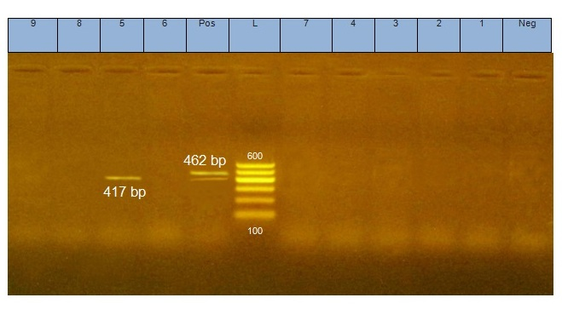
Figure (1): Agarose gel electrophoresis for amplified PCR product of quinolone resistance genes (qnrS) and β-Lactamase (blaCMY-2) in different Salmonella isolates
L ( DNA ladder 100 - 600 bp)
Neg (Negative control ), Pos ( positive control ) Positive and negative controls were recovered from previously tested and confirmed field isolates (Tested in the Reference laboratory for veterinary quality control on poultry production), Lane (1- 9) Salmonella isolates from chicken :
Lane 1,2,8 ( S.Infantis) ,Lane 3 (S.Ratchaburi ) , Lane 4 (S.Sinchew) ,
Lane 5 (S.Magerhafelt), Lane 6, (S.Stanleyville) , Lane 7,9 (S.Typhimurum )
(Amplicons of qnrS gene detected in lane 5 (S.Magerhafelt) at 417 bp )
( No amplicons of blaCMY-2 detected in any of Salmonella isolates tested at 462 bp )

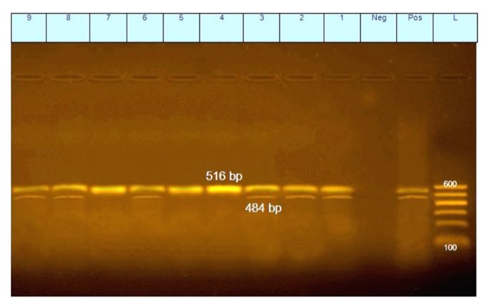

Figure (2): Agarose gel electrophoresis for amplified PCR product of the β-Lactamase gene (blaTEM) and of the Aminoglycoside resistance gene (aadA1) in different Salmonella isolates
L ( DNA ladder 100 - 600 bp) ,
Neg (Negative control ) ,Pos ( positive control) , Positive and negative controls were recovered from previously tested and confirmed field isolates (Tested in the Reference laboratory for veterinary quality control on poultry production), Lane (1- 9 ) Salmonella isolates from chicken : Lane 1,2, 8 ( S.Infantis) ,Lane 3 (S.Ratchaburi ) , Lane 4 (S.Sinchew) , Lane 5 (S.Magerhafelt), Lane 6, (S.Stanleyville) , Lane 7,9 (S.Typhimurum )
(Amplicons of blaTEM gene detected in lane 1, 2, 3, 4, 5, 6, 7,8 and 9 at 516 bp.) (Amplicons of aadA1 gene detected in lane 1, 2, 3, 6, 8 and 9 at 484 bp)

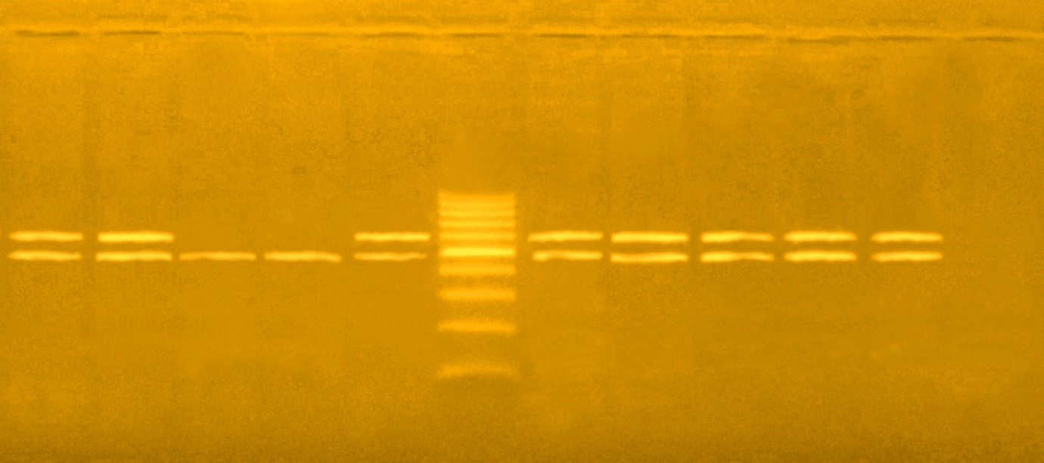  9 | 8 | 7 | 6 | Pos | L | 5 | 4 | 3 | 2 | 1 | Neg
600

100

300

100

576 bp

1500

300

100

494 bp

1500

300

100

Figure (3): Agarose gel electrophoresis for amplified PCR product of tetracycline resistance gene (tetA) and chlorompenicol resistance gene ( floR) in different Salmonella isolates.
L ( DNA ladder 100 - 600 bp)
Pos ( positive control) , Neg (Negative control ) Positive and negative controls were recovered from previously tested and confirmed field isolates (Tested in the Reference laboratory for veterinary quality control on poultry production)
Lane (1- 9) Salmonella isolates from chicken : Lane 1,2, 8 ( S.Infantis) ,
Lane 3 (S.Ratchaburi) , Lane 4 (S.Sinchew) , Lane 5 (S.Magerhafelt), Lane 6 (S.Stanleyville) ,Lane 7,9 (S.Typhimurum )
( Amplicons of tetA gene detected in lane 1 , 2 , 3 , 4 , 5 , 8 , 9 at 576 bp )
( Amplicons of floR gene detected in lane 1,2 , 3,4,5,6,7,8, and 9 at 494 bp)

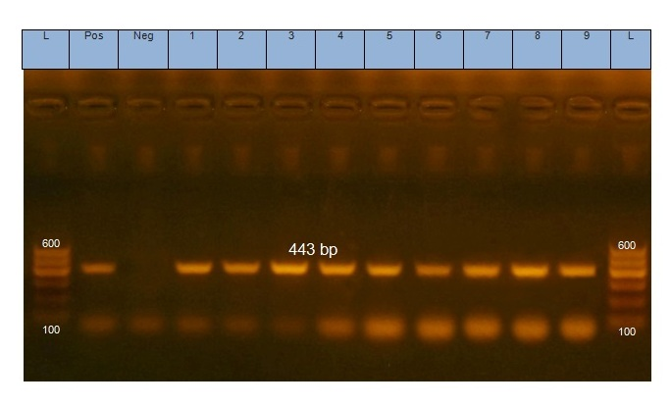
Figure(4) : Agarose gel electrophoresis for amplified PCR product of sulphonamide resistance gene (sul 1) in different salmonella isolates
L ( DNA ladder 100 - 600 bp)
Neg (Negative control), Pos( positive control) Positive and negative controls were recovered from previously tested and confirmed field isolates (Tested in the Reference laboratory for veterinary quality control on poultry production), Lane (1- 9 ) Salmonella isolates from chicken : Lane 1, 2, 8 ( S.Infantis) ,
Lane 3 (S.Ratchaburi ) , Lane 4 (S.Sinchew) , Lane 5 (S.Magerhafelt),
Lane 6 (S.Stanleyville) ,Lane 7,9 (S.Typhimurum )
(Amplicons of sul1 gene detected in lane 1, 2, 3, 4, 5, 6,7,8 and 9 at 443 bp).

494 b 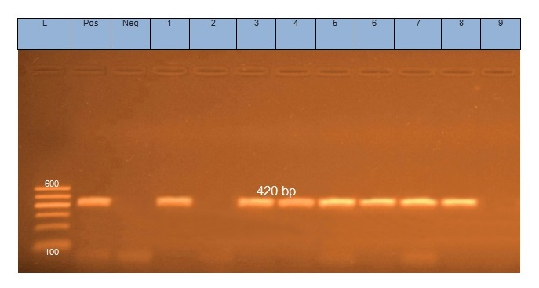
Figure (5) : Agarose gel electrophoresis for amplified PCR product of Macrolide resistace gene (ereA) in different Salmonella isolates.
L ( DNA ladder 100 - 600 bp)
Neg (Negative control) , Pos ( positive control) Positive and negative controls were recovered from previously tested and confirmed field isolates (Tested in the Reference laboratory for veterinary quality control on poultry production), Lane (1- 9 ) Salmonella isolates from chicken :Lane 1,2, 8 ( S.Infantis) ,
Lane 3(S.Ratchaburi ) ,Lane 4 (S.Sinchew) , Lane 5 (S.Magerhafelt),
Lane 6, (S.Stanleyville) , Lane 7,9 (S.Typhimurum )
( Amplicons of ereA gene detected in lane 1, 3, 4, 5, 6, 7 and 8 at 420 bp).

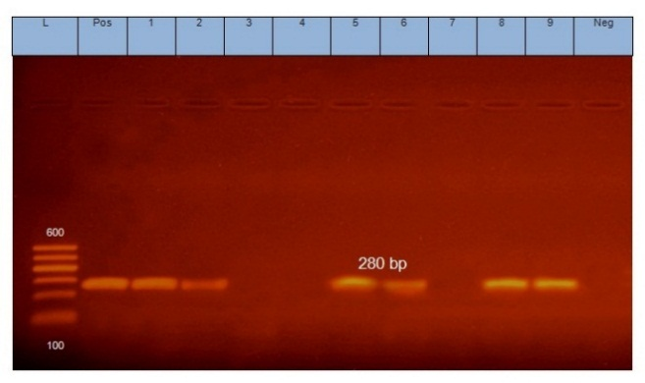

Figure (6) : Agarose gel electrophoresis for amplified PCR product of Integron gene cassette (int1) in different Salmonella isolates.
L( DNA ladder 100 - 600 bp)
Neg (Negative control ) , Pos ( positive control), Positive and negative controls were recovered from previously tested and confirmed field isolates (Tested in the Reference laboratory for veterinary quality control on poultry production), Lane (1- 9) Salmonella isolates from chicken : Lane 1,2,8 ( S.Infantis) ,
Lane3 (S.Ratchaburi ) , Lane 4 (S.Sinchew) , Lane 5 (S.Magerhafelt),
Lane 6 (S.Stanleyville) ,Lane 7,9 (S.Typhimurum )
(Amplicons of int1 gene detected in lane 1, 2, 5, 6,8 and 9 at 280 bp).

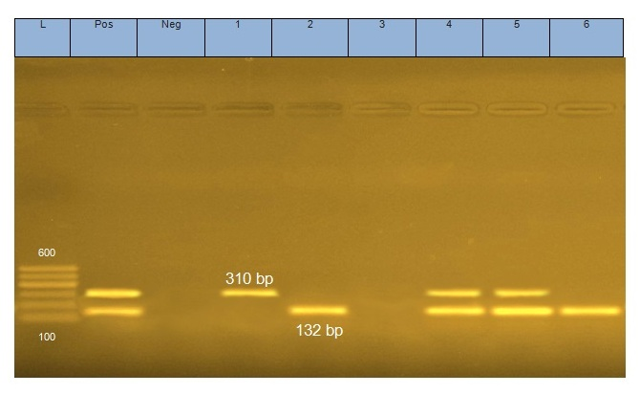
Figure ( 7 ) : Agarose gel electrophoresis for amplified PCR product of Methicillin resistance gene (mecA) and (femA) in different S.aureus isolates

L ( DNA ladder 100 - 600 bp)
Pos ( positive control : reference strain deposited to gene bank with MRSA ATCC 43300 , Neg (Negative control: negative controls were recovered from previously tested and confirmed field isolates -Tested in the Reference laboratory for veterinary quality control on poultry production)
Lane (1- 6 ) S.aureus isolate.
( Amplicons of mecA gene detected in lane 1, 4 and 5 at 310bp) ,
( Amplicons of femA gene detected in lane 2, 4, 5 and 6 at 132bp)

